MARHOLM PARISH COUNCIL
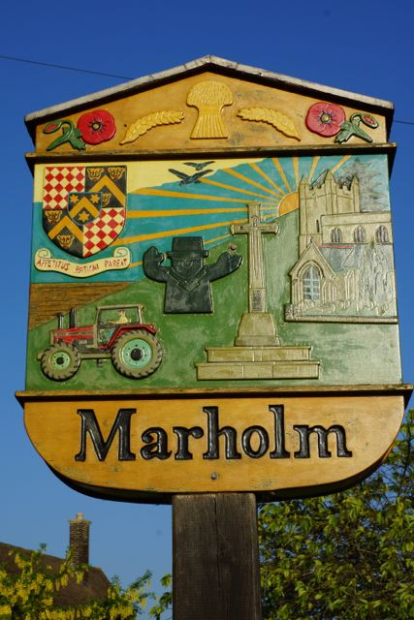
MEETING TO BE HELD ON
THURSDAY 13 March 2025 at 7.00pm
MARHOLM VILLAGE HALL

AGENDA

- Minutes of Parish Council Meeting held on 16 January
- Apologies for absence
- Parish Clerk vacancy. This is now urgent as Chair can no longer do it alone
- Outstanding items from previous meetings:

  - 30 mile an hour sign on Woodcroft road
  - Extra rubbish bin on Woodcroft Road
  - Bus consultation

- MPC Finance – should we research new bank account as Lloyds have started to charge fees
- Planning Applications
- VE signs for lampposts
- State of cattle crossing and stile at entrance to Church Meadow
- Walking Group update
- Speedwatch volunteers
- Marque donation for village use
- Litter picking date
- AOB

