MARHOLM PARISH COUNCIL
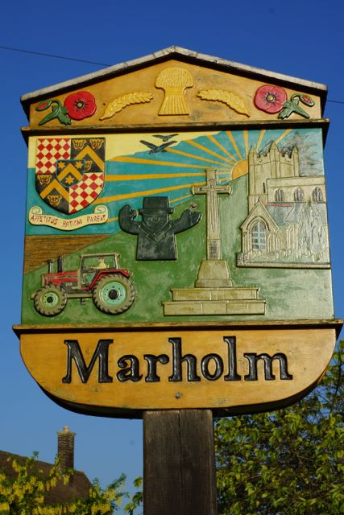
MEETING TO BE HELD ON
THURSDAY 15th JANUARY 2025 AT 7:15PM
MARHOLM VILLAGE HALL

AGENDA

- Minutes of Parish Council Meeting on 11th November 2025
- Outstanding items from previous Parish Council Meeting
- MPC Finances
- Neighbourhood Watch
- Grant for Speed reduction
- Precept
- Planning Applications
- Village Litter Pick
- Speed Watch
- AOB

